File Operation Commands
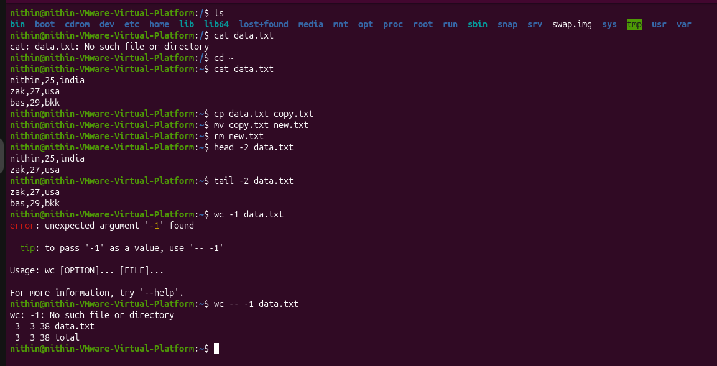
I have used all file operation commands ls, cat, cp, mv, rm, head, tail, wc.
For search in text files
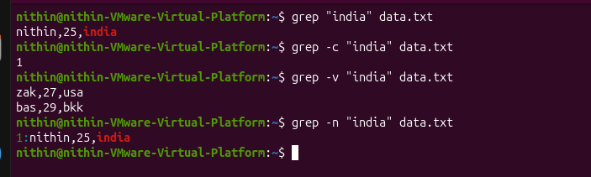
using (grep) we can search text in files.
Printed columns using (awk)
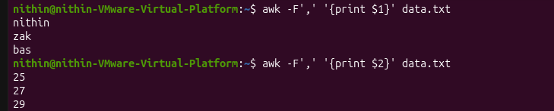
awk is used for data extraction, text processing & reporting.
Text substitution used sed
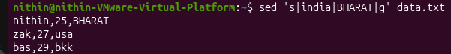
sed is used for transform, filter, and manipulate text as it flows through a stream.
Echo
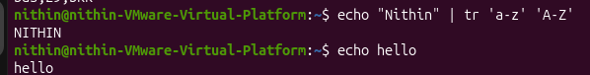
echo to display text or variables on your terminal screen
To compress or extract files “tar”

Superuser do (sudo)
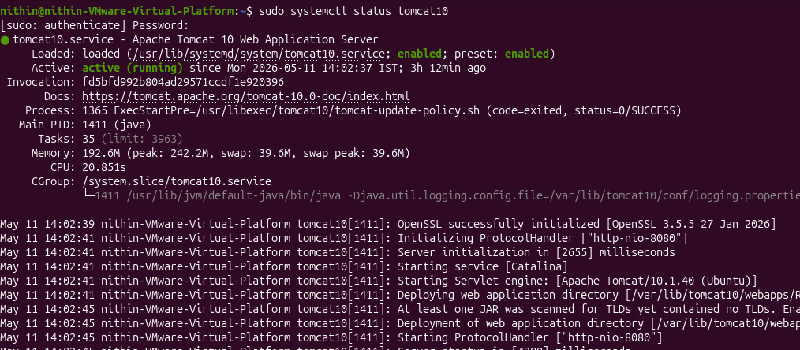
Used sudo to run command as administrator & used systemctl cmd to start, stop, check status & enabled.
SSH and Network cmd
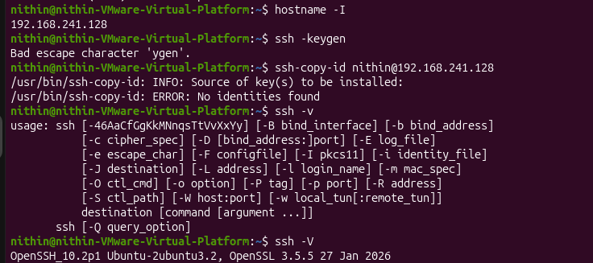
ssh is used to connect and remote server login. Network I have used hostname to check ip address.
Merge files
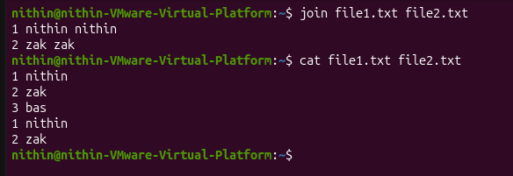
For merging file, I used join cmd to merge the lines of two files based on a common field.
Chmod
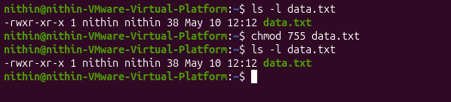
chmod changes file permissions & it will remove write permissions to all others in system except owner.
Chown
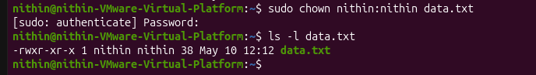
Change / assign owner
Mount & fdisk
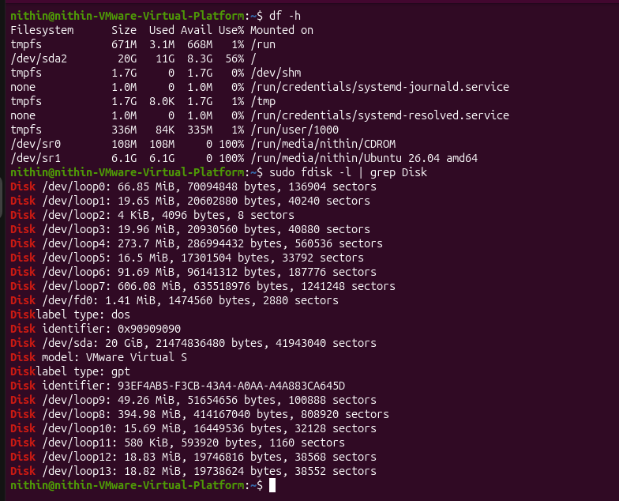

Nmap
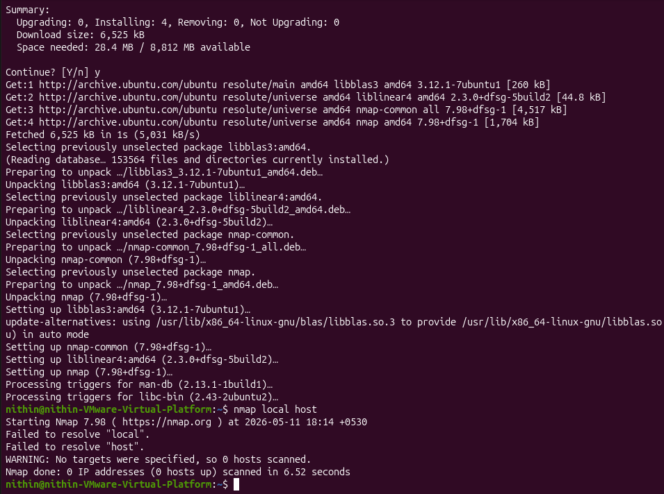
installed nmap using sudo apt install nmap
Dig
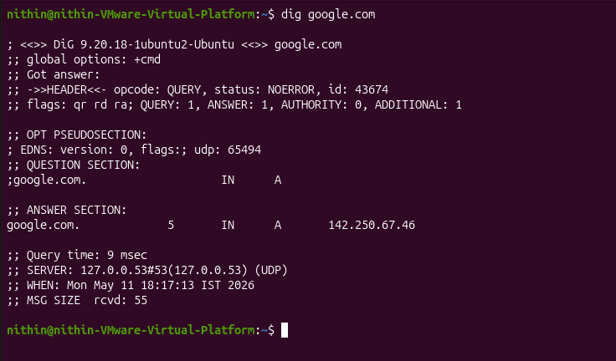
DNS troubleshooting

